**T2/T3 unlimited:**

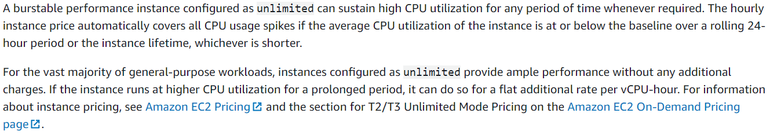

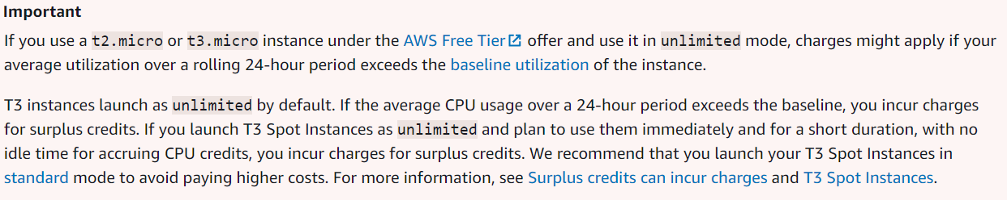

We can add this feature while creating the instance as below

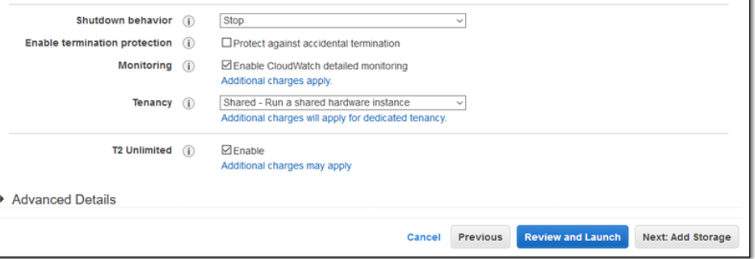

Or we can add it later after creating the instance as below.

